Jennifer DeVore

19 March 2020

Cis 435

**Course Case Study Project Submission Part A**

**Part A: Create the database**

**Screenshot of Script before being run with name**

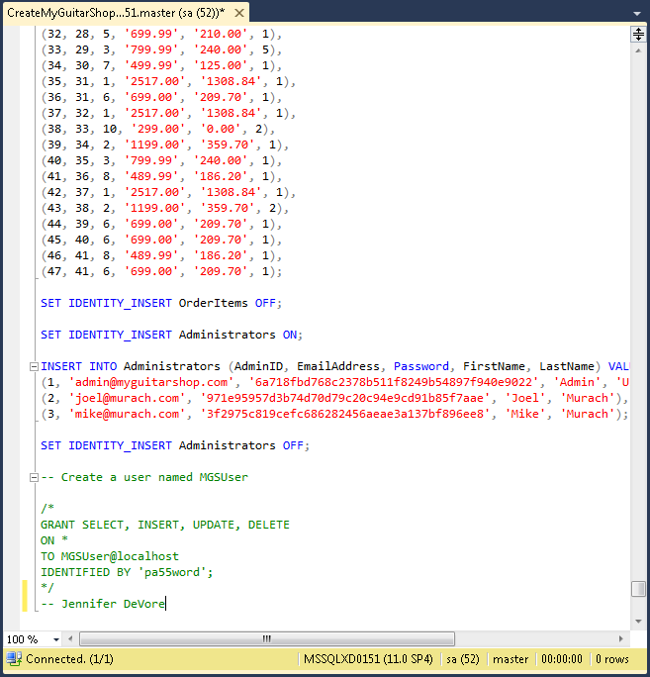

**After being run**

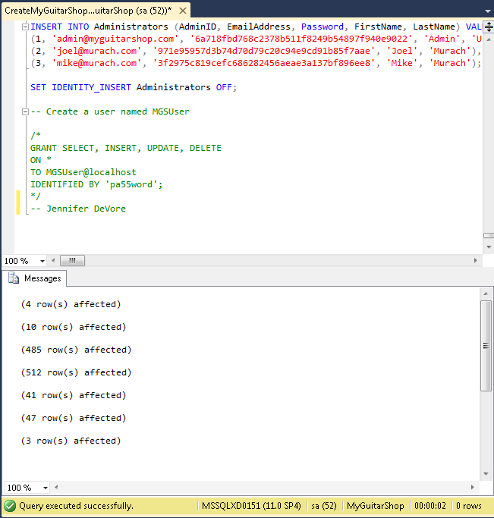

**Showing that the DB now exists in the Object Explorer**

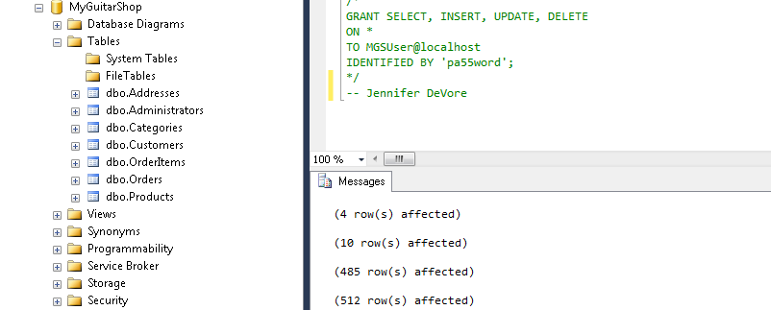

**Diagram of MyGuitarShop Database with relationships and keys**

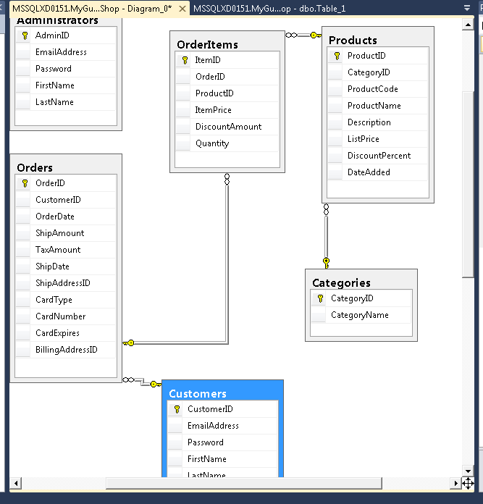

**Screenshot showing two separate queries run on the MyGuitarShop DB**

